ENGR 10

Homework 1

Please check your work before you upload it. Problems that do not run will not be considered for credit.

1. Which of the following names is a valid Matlab filename?

Fred Fred1 book\_1 book-1

2ndplace Secondplace #1 No\_1

Vel\_5 Vel.5 sin while

Test your answers before you upload them.

1. The area of a circle is πr2. The surface area of a sphere is 4πr2. The volume of a sphere is 4/3πr3.
   1. If r =27.5, write a Matlab program that will print the area of the circle defined by r.
   2. If r = 27.5, write a Matlab program that will print the surface area of the sphere defined by r.
   3. If r = 27.5, write a Matlab program that will print the volume of the sphere defined by r.
2. The response of circuits defined by resistors, capacitors and inductors depends on the relative value of the resistors and the way they are connected. An important intermediate quantity used to describe the response of the circuit is S. Depending on the values of R, C and L, the value of S will be either real or complex or a duplicated value. Use the Help function in Matlab to find the proper way to print complex numbers. The equation that defines the response is:

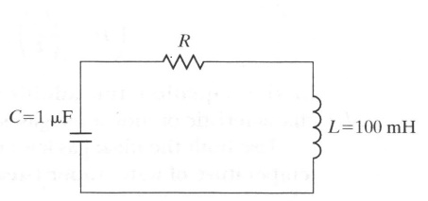

RCL_formula.JPG

* 1. Determine the value(s) of S for R=400 Ω.

1. We know the earth and moon are not always the same distance apart. Determine and print the force the moon exerts on the earth for 12 distances from 3.56 x 108 and 4.06 x 108 meters. Be careful not to confuse mass m and distance in meters m.

F= G m1m2/r2

G is 6.673 x 10-11 Nm2/kg2

The mass of the earth is 5.974 x 1024 kg

The mass of the moon is 7.347 x 1022 kg

Submit problem #1 as a Word doc or docx file. Submit the other questions as .M files to Coursesite by Midnight next Tuesday. If you are using an Apple computer ensure that the name of the program you uploaded to Coursesite is a valid file name. Do not submit Excel or other programs.